

**Product Dissection for OYO Rooms.**

**Company Overview:**

OYO Rooms (stylised as OYO), also known as OYO Hotels & Homes, is an Indian multinational hospitality chain of leased and franchised hotels, homes, and living spaces. OYO Hotels & Homes was founded by Ritesh Agarwal, the first resident Asian to be accepted to the Thiel Fellowship (started by Paypal founder Peter Thiel). Travelling across India at the age of 17, Ritesh stayed in more than 100 bed and breakfasts, guest houses, and hotels to realize there was a massive dearth of affordable and good-quality hotels in the unbranded budget hotel category.

**Product Dissection and Real-World Problems Solved by OYO :**

Oyo, a leading name in the hospitality industry, has effectively tackled several real-world challenges through its innovative approach to hotel management and booking. Prior to Oyo, travellers often faced inconsistent quality and unreliable service in budget accommodations, leading to uncertainty and dissatisfaction. Oyo addressed this by standardizing its partner hotels, ensuring that every room meets strict quality benchmarks for cleanliness, amenities, and service. This core feature solves the problem of unreliable hotel experiences, offering travellers a dependable and consistent stay, no matter where they book.

Oyo has also revolutionized the accessibility of affordable accommodations, particularly in underserved regions. Many travellers struggled to find budget-friendly and well-located options in smaller towns and cities. Oyo’s extensive network and user-friendly app have made it easier to discover and book affordable stays in these areas. By providing real-time room availability, secure payment options, and a seamless booking process, Oyo has addressed the challenge of limited access to budget accommodations, making travel more convenient for a wider audience.

For hotel owners, Oyo has solved the problem of low occupancy and inefficient revenue management. Joining the Oyo platform provides hotels with increased visibility and access to a broader customer base, leading to higher booking rates. Oyo’s dynamic pricing model and revenue management tools help optimize room rates based on demand, enhancing profitability. By addressing these key issues, Oyo has not only transformed the guest experience but also provided valuable solutions for hotel operators, making it a significant player in the hospitality industry.

**Case Study: Real-World Problems and OYO's Innovative Solutions**

Oyo has adeptly addressed real-world challenges in the hospitality industry by standardizing budget accommodations to ensure consistent quality and reliability for travellers. By creating a network of vetted hotels and offering a user-friendly app, Oyo has made it easier for users to find and book affordable stays, even in underserved regions. Additionally, Oyo has enhanced hotel visibility and optimized revenue management for hotel owners through its dynamic pricing model and extensive platform reach. These innovations have transformed the hotel experience, making travel more dependable and accessible while boosting profitability for hotel operators.

**Problem 1: Inconsistent Quality in Budget Accommodations**

**Real-World Challenge:** Budget travellers often encounter unpredictable quality in hotel stays. Many budget accommodations lack standardization, leading to varied experiences in terms of cleanliness, amenities, and overall service. This inconsistency creates uncertainty and dissatisfaction among travellers.

**Oyo's Solution:** Oyo addressed this issue by implementing a rigorous standardization process for its partner hotels. By setting strict quality benchmarks and auditing properties, Oyo ensures that all hotels on its platform provide a consistent level of service and amenities. This approach guarantees that travellers can expect a reliable and uniform experience, regardless of the location, thus enhancing trust and satisfaction in budget accommodations.

**Problem 2: Limited Accessibility to Affordable Accommodations**

**Real-World Challenge:** Finding affordable and well-located hotels in smaller cities and towns can be challenging. Many travellers struggle to locate budget-friendly options outside major metropolitan areas, limiting their travel choices.

**Oyo's Solution:** Oyo expanded accessibility to affordable accommodations by partnering with hotels in previously underserved regions. Its extensive network and user-friendly app make it easier for users to discover and book budget-friendly stays in these areas. By providing real-time availability, secure payment options, and a seamless booking experience, Oyo addresses the challenge of accessing affordable lodging, making travel more convenient and accessible for a broader audience.

**Problem 3: Low Occupancy and Inefficient Revenue Management for Hotels**

**Real-World Challenge:** Many small hotels struggle with low occupancy rates and inefficient revenue management. These hotels often lack the resources and tools to optimize room rates and attract customers effectively.

**Oyo's Solution:** Oyo provides hotel owners with increased visibility through its platform, driving higher occupancy rates. The dynamic pricing model adjusts room rates based on demand, helping hotels optimize revenue. Additionally, Oyo offers tools for better inventory management and marketing, enabling hotel operators to enhance profitability. This support addresses the challenges of low occupancy and inefficient revenue management, benefiting both hotel operators and travellers.

**Problem 4: Lack of Reliable Customer Service and Booking Transparency**

**Real-World Challenge:** Travelers often face issues with booking transparency and customer service, such as hidden charges or difficulties in resolving complaints. This lack of reliability can lead to frustration and a negative travel experience.

**Oyo's Solution:** Oyo tackles these issues by offering transparent pricing with no hidden charges and providing robust customer support. The platform's app ensures clear communication regarding booking details, payment processes, and cancellation policies. Additionally, Oyo’s customer service team is available to address any issues or complaints, ensuring a smooth and reliable booking experience. This approach enhances trust and satisfaction by resolving concerns and providing clarity throughout the booking process.

**Problem 5: Inefficient Hotel Operations**

**Real-World Challenge:** Many small hotels struggle with inefficient operations, including poor management of bookings, housekeeping, and maintenance. These inefficiencies can lead to subpar guest experiences and operational challenges.

**Oyo's Solution:** Oyo provides hotel partners with a comprehensive management system that streamlines operations. This system includes tools for booking management, housekeeping schedules, and maintenance tracking. By integrating these operational aspects into a unified platform, Oyo helps hotels run more efficiently and improve overall guest satisfaction.

**Problem 6: Inconsistent Pricing**

**Real-World Challenge:** Travelers often encounter inconsistent pricing for hotel rooms, which can lead to confusion and dissatisfaction. Prices may vary significantly depending on the booking channel or the time of booking.

**Oyo's Solution:** Oyo’s dynamic pricing model ensures that room rates are adjusted based on demand, location, and other factors. This approach provides more consistent pricing and helps prevent price discrepancies, making it easier for travellers to understand and trust the rates they see. Additionally, Oyo’s platform offers transparent pricing with no hidden fees, further improving the booking experience.

**Problem 7: Limited Marketing and Visibility for Small Hotels**

**Real-World Challenge:** Small hotels frequently struggle with limited marketing resources and visibility, making it hard for them to attract guests and compete with larger establishments.

**Oyo's Solution:** Oyo’s platform provides extensive marketing support and visibility for small hotels. By listing on Oyo, hotels gain access to a large customer base and benefit from Oyo’s marketing efforts, including online advertising and promotions. This increased visibility helps attract more bookings and improves the hotel's competitive edge.

**Conclusion:**

Oyo’s evolution from a budget accommodation aggregator to a leading hospitality brand exemplifies its commitment to solving real-world problems with innovative solutions. By standardizing hotel quality, enhancing accessibility to affordable lodging, optimizing hotel operations, and providing transparent pricing, Oyo has addressed key challenges in the hospitality industry. This case study highlights how Oyo’s user-centric approach and operational advancements have transformed the hotel experience, making travel more reliable and accessible while supporting hotel partners in managing their businesses effectively.

**Top Features of Oyo:**

1. **Standardized Quality Assurance:** Oyo ensures consistent quality across its partner hotels by implementing rigorous standards and regular audits. This feature addresses the issue of inconsistent quality in budget accommodations, providing travellers with a reliable and uniform experience.
2. **Wide Accessibility:** Through its extensive network and user-friendly app, Oyo enhances accessibility to affordable accommodations, even in underserved regions. This feature makes it easier for travellers to find and book budget-friendly stays, expanding their travel options.
3. **Dynamic Pricing Model:** Oyo’s dynamic pricing model adjusts room rates based on demand and location, offering consistent pricing and optimizing revenue for hotel partners. This feature solves the problem of inconsistent pricing and helps hotels maximize their profitability.
4. **Comprehensive Hotel Management System:** Oyo provides hotel partners with tools for efficient management of bookings, housekeeping, and maintenance. This feature streamlines operations and improves overall guest satisfaction by addressing inefficiencies in hotel management.
5. **Transparent Booking Experience:** Oyo offers transparent pricing with no hidden charges and robust customer support. This feature ensures clarity in the booking process and resolves concerns, enhancing trust and reliability for travellers.
6. **Enhanced Marketing and Visibility:** By listing on Oyo, hotels gain increased visibility and benefit from Oyo’s marketing efforts. This feature helps small hotels attract more bookings and compete effectively in the hospitality market.

**Schema Description for Oyo:**

The schema for Oyo includes several key entities to manage its hotel booking and management system. These entities are Customer, Hotel, Room, Booking, Payment, Review, Complaint. Each entity plays a crucial role in ensuring a smooth operation of the platform, from handling customer interactions and bookings to managing payments and feedback. This structured schema supports the effective management of hotel operations and customer service, enhancing both user experience and operational efficiency.

**Customer Entity:**

The Customer entity represents the users who book rooms at hotels through Oyo.

* **CustomerID (Primary Key):** A unique identifier for each customer.
* **Name:** The full name of the customer.
* **Email:** The customer's email for communication and receiving updates.
* **PhoneNumber**: The customer's phone number for communication and support.
* **RegistrationDate:** The date when the customer registered on Oyo.

**Hotel Entity:**

The Hotel entity represents the hotels partnered with Oyo.

* **HotelID (Primary Key):** A unique identifier for each hotel.
* **Name:** The name of the hotel.
* **Location:** The address of the hotel.
* **Rating:** The overall rating of the hotel.
* **Price:** The base price for booking rooms at the hotel.

**Room Entity:**

The Room entity represents individual rooms within hotels.

* **RoomID (Primary Key):** A unique identifier for each room.
* **HotelID (Foreign Key referencing Hotel Entity):** The hotel that owns the room.
* **RoomType:** The type/category of the room (e.g., Deluxe, Standard, Suite).
* **Price:** The price of the room.
* **Availability:** A flag indicating if the room is available for booking.

**Booking Entity:**

The Booking entity represents the reservations made by customers.

* **BookingID (Primary Key):** A unique identifier for each booking.
* **CustomerID (Foreign Key referencing Customer Entity):** The customer who made the booking.
* **HotelID (Foreign Key referencing Hotel Entity):** The hotel being booked.
* **RoomID (Foreign Key referencing Room Entity):** The room being booked.
* **BookingDate:** The date when the booking was made.
* **Duration:** The length of stay (in days).
* **Status:** The status of the booking (e.g., Confirmed, Cancelled, Completed).
* **TotalPrice:** The total price for the booking (calculated based on room price and duration).

**Payment Entity:**

The Payment entity records payments made by customers.

* **PaymentID (Primary Key):** A unique identifier for each payment.
* **BookingID (Foreign Key referencing Booking Entity):** The booking associated with the payment.
* **CustomerID (Foreign Key referencing Customer Entity):** The customer who made the payment.
* **CustomerName:** The name of the customer who made the payment (for quick reference).
* **Amount:** The total amount paid.
* **PaymentDate:** The date the payment was made.
* **PaymentMode:** The mode of payment (e.g., Credit Card, Debit Card, UPI, Net Banking, etc.).
* **Status:** The status of the payment (e.g., Pending, Completed).

**Complaint/Query Entity:**

This entity represents customer complaints and queries raised about their experience with the service.

* **ComplaintID (Primary Key):** A unique identifier for each complaint or query.
* **CustomerID (Foreign Key referencing Customer Entity):** The customer who raised the complaint or query.
* **CustomerName:** The name of the customer for reference.
* **BookingID (Foreign Key referencing Booking Entity):** The booking related to the complaint (if applicable).
* **ComplaintText:** A description of the issue or query raised by the customer.
* **ComplaintDate:** The date when the complaint or query was submitted.
* **Status:** The current status of the complaint/query (e.g., Open, In Progress, Resolved, Closed).
* **ResolutionDetails:** Details about how the complaint was resolved (if applicable).

**Review Entity:**

The Review entity allows customers to leave feedback for hotels.

* **ReviewID (Primary Key):** A unique identifier for each review.
* **CustomerID (Foreign Key referencing Customer Entity):** The customer who wrote the review.
* **HotelID (Foreign Key referencing Hotel Entity):** The hotel being reviewed.
* **Rating:** The rating given by the customer (out of 5).
* **Comments:** The written feedback provided by the customer.
* **ReviewDate:** The date the review was posted.

**Relationship Summary:**

**• Customer ↔ Booking**: A customer can make multiple bookings. The CustomerID in the Booking entity references the CustomerID in the Customer entity.

**• Hotel ↔ Room:** A hotel can have multiple rooms. The HotelID in the Room entity references the HotelID in the Hotel entity.

**• Hotel ↔ Booking:** A booking is associated with a hotel. The HotelID in the Booking entity references the HotelID in the Hotel entity.

**• Room ↔ Booking:** A booking includes one specific room. The RoomID in the Booking entity references the RoomID in the Room entity.

**• Booking ↔ Payment:** A booking has an associated payment. The BookingID in the Payment entity references the BookingID in the Booking entity.

**• Customer ↔ Payment:** A customer can make multiple payments. The CustomerID in the Payment entity references the CustomerID in the Customer entity.

**• Customer ↔ Complaint/Query:** A customer can raise multiple complaints or queries. The CustomerID in the Complaint/Query entity references the CustomerID in the Customer entity.

**• Booking ↔ Complaint/Query:** A complaint or query can be related to a specific booking. The BookingID in the Complaint/Query entity references the BookingID in the Booking entity.

**• Hotel ↔ Review:** A review is associated with a specific hotel. The HotelID in the Review entity references the HotelID in the Hotel entity.

**• Customer ↔ Review:** A customer can leave multiple reviews. The CustomerID in the Review entity references the CustomerID in the Customer entity.

**ER Diagram:**

Let's construct an ER diagram that vividly portrays the relationships and attributes of the entities within the Oyo booking system. This ER diagram will serve as a visual representation, shedding light on the pivotal components of Oyo's data model. By employing this diagram, you'll gain a clearer grasp of the intricate interactions and connections that define the platform's booking, payment, and customer management dynamics.

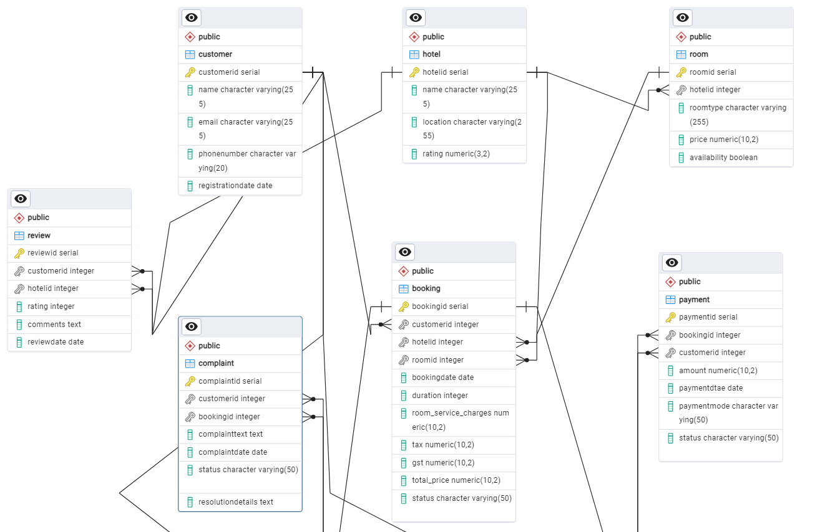

**Conclusion:**

In this case study, we explored the design of Oyo's booking system schema and Entity-Relationship diagram. Oyo has transformed the way customers book hotels, offering convenience and streamlined experiences for both travelers and hotel owners. The platform’s intricate data model, consisting of entities like customers, hotels, rooms, bookings, payments, complaints, and reviews, forms the backbone of its efficient operations. By understanding this schema, we gain insight into how Oyo effectively manages the complexities of customer interactions, hotel partnerships, and booking processes, contributing to its success and continued growth in the hospitality industry.